Stories of Migration
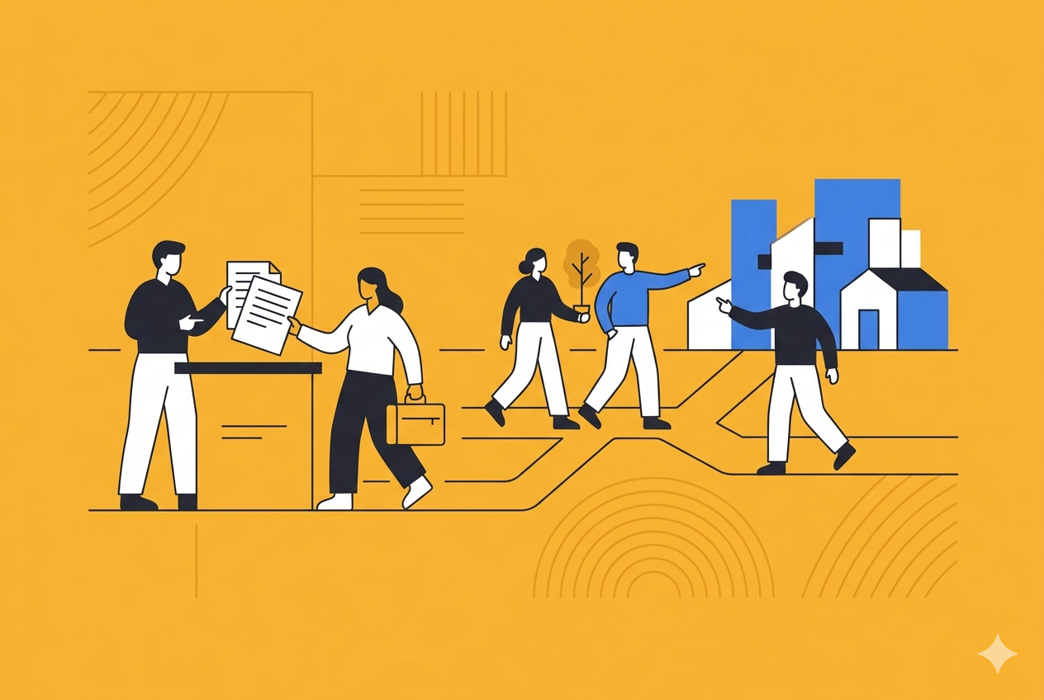
- Grade Level: 4-6
- Duration: 60 minutes
- Subject: Other Social Studies
- Interdisciplinary Connection: Mathematics
- Platform: Scratch
This lesson guides learners in Grades 4–6 to create a digital animation in Scratch that narrates their family's immigration story. Through this project, students explore concepts such as migration, emigration, and immigration while applying fundamental coding principles like Algorithms, Sequence, and Events.

Curricular Connections

Ontario
Overall Expectation (O.E.): A1. Application: Past and Present Societies: compare key aspects of life in a few early societies (to 1500)... and describe some key similarities and differences between these early societies and present-day Canadian society.

Specific Expectation (S.E.): A1.3 describe some of the ways in which their daily life differs from the lives of young people from different backgrounds (e.g., wealthy, poor, slave, urban, rural) in a few early societies...(with reference to family life, education, leisure time and recreation, responsibilities, work).

Quebec
Expectation 1 (Cycle 3/Grade 6 - Diversity/Composition): Describes the composition of the population: Native peoples (Amerindian and Inuit), people of French and British descent, people of other origins. Expectation 2 (Technical Skill/Research): Gathers and processes information: Collects data.

Objectives

Learning Goals
Students will be able to...
- Define migration, emigration, and immigration.
- Apply the coding concepts of Algorithms, Sequence, and Events to create a digital narrative.
- Research and communicate their family’s immigration story (or an historical figure's story) through a multi-scene animation
Success Criteria
I can...
- I can explain the difference between migration, emigration, and immigration.
- I can use Scratch coding blocks to create an animated story using sequence and events.
- I can tell a compelling story about an immigration experience using multiple backgrounds and “Say” scripts.

Material
Required Materials
- Computers with either the Scratch offline editor installed, or with access to the internet.
Optional Materials
- Article for Canadian examples of immigrants.
- Scratch challenge solutions document.
- Research materials (digital or print) on family history or historical figures.

Lesson

Activity | Description
Prior Knowledge | - Basic knowledge of computer operations and navigation (e.g., opening a browser or program).  - Awareness that families may have moved from one place to another (migration).
Minds On | 5-10 minutes  Initiate discussion using the guiding question: Q: What is migration? What are different kinds of migration?  Define key terms:  Migration is the movement from one country or region to another.  Emigration is when you leave your own country.  Immigration is when someone moves to live in a new country.  Introduce the project: Today’s Project: We are creating an animation in Scratch to tell our family’s immigration story. Note the option to research an historical figure's story if the family story is difficult to tell.
Model | 15 minutes  Give learners 2-3 minutes to explore example “Immigration Experience” projects in Scratch. Open one of the examples and click “See Inside.” Work together to break down the project. Explain that the animations will need:  A sprite or main character  Multiple backgrounds for our story  An event to start the story (e.g. when the green flag is clicked)  “Switch Backdrop” scripts to change the background images  “Say” scripts to tell our story  Success Criteria: Co-create success criteria with the class based off of the example projects.
Practice | 30 minutes  Provide time for learners to create their immigration stories. Students work independently to apply the concepts (Algorithms, Sequence, Events) and technical instructions (sprites, backdrops, say scripts) to build their digital narrative. Circulate to provide targeted assistance and support.
Consolidation | 10 minutes  If time, have learners present their projects and share their immigration stories with the class. Review the definitions of migration, emigration, and immigration, and identify the coding concepts (Sequence, Events) used in the shared projects.
Modifications & Accommodations | - Sensitive Content: Give learners the option to tell their own story, or to research the story of someone else (e.g. historical figure). This is particularly important because ""some immigration stories might be traumatic or difficult stories to tell"".  - Coding Support: For learners struggling with Scratch, provide pre-written blocks or pair them with a peer to reinforce the use of Events and Sequence.

Assessment

Summative
Use the co-created success criteria to create a rubric for assessment. The assessment should measure the student's ability to communicate the immigration story and successfully apply the required coding concepts (Sequence, Events). For submission, consider creating a Scratch Teacher Account and class for learners to submit their projects.

Extension

Cross Curricular Connections
Mathematics (Data Management/Coding): Learners are sequencing events in a narrative (A timeline of movement). They can use coding to collect or display historical data.

Language Arts/Media Literacy: Focusing on narrative structure, dialogue, and script writing.

Extend Your Thinking
- Challenge learners to also record their voice and narrate their story.
- Talk about reasons why someone might move to another country, including refugees fleeing a crisis in their home country.
- Discuss how we might make newcomers feel more welcome in Canada, and work in groups to brainstorm and share solutions.

